
The School of Technology
BSc (Hons) in Software Engineering
(Batch - 08)
Software Architecture and Design
4CS017
W.Udara Nethmi(2501573)
Module Leader: Ms. Suranji Nadeeshani
Submission Date: 06/11/2024

This weather application integrates three core technologies. Java Script, HTML, and PHP. The primary objective was to develop an interactive web- based application that allows users to search for weather data by entering the name of a city. The application checks if the requested data exists in the database, and if not, it fetches the data from an external weather API, ensuring the user is always provided with the most up-to-date information.
HTML Structure : Creating a basic web page with input fields for the location for displaying weather data. CSS Styling : Styling the app Java Script Integration : Implementing the logic to fetch weather data from the open weather map API using java script. API Integration : The open weather map API was used to provide real time weather information. An API Key was used to authenticate requests and fetch data. PHP :Generate dynamic content and interact with database to create interactive web application.

The weather app I developed effectively fetches and displays weather data using both sources, ensuring data availability even if one source is down. The dynamic display that updates weather information based on user input enhances the user experience. The app also handles errors will by providing clear feedback when the city is not found or if the request fails. Additionally, the combination of Java Script for user interactions and PHP for real-time data fetching makes the app responsive.
The app has several weaknesses to address. The PHP script’s security can be improved to prevent SQL injection, especially by parameterizing the query fetching city data. Additionally, the app lacks proper error handling and input validation, which could cause issues with unexpected inputs. The frontend design, while functional, would benefit from a more responsive layout for different screen sizes, as the current background image may not display well on all devices. Adding visual elements like weather icon or a temperature scale switch would further enhance user engagement.
In conclusion, while the app is functional and useful, improving security, usability, and design would significantly boost its overall performance.

The codes are given below.
This is my HTML Code.
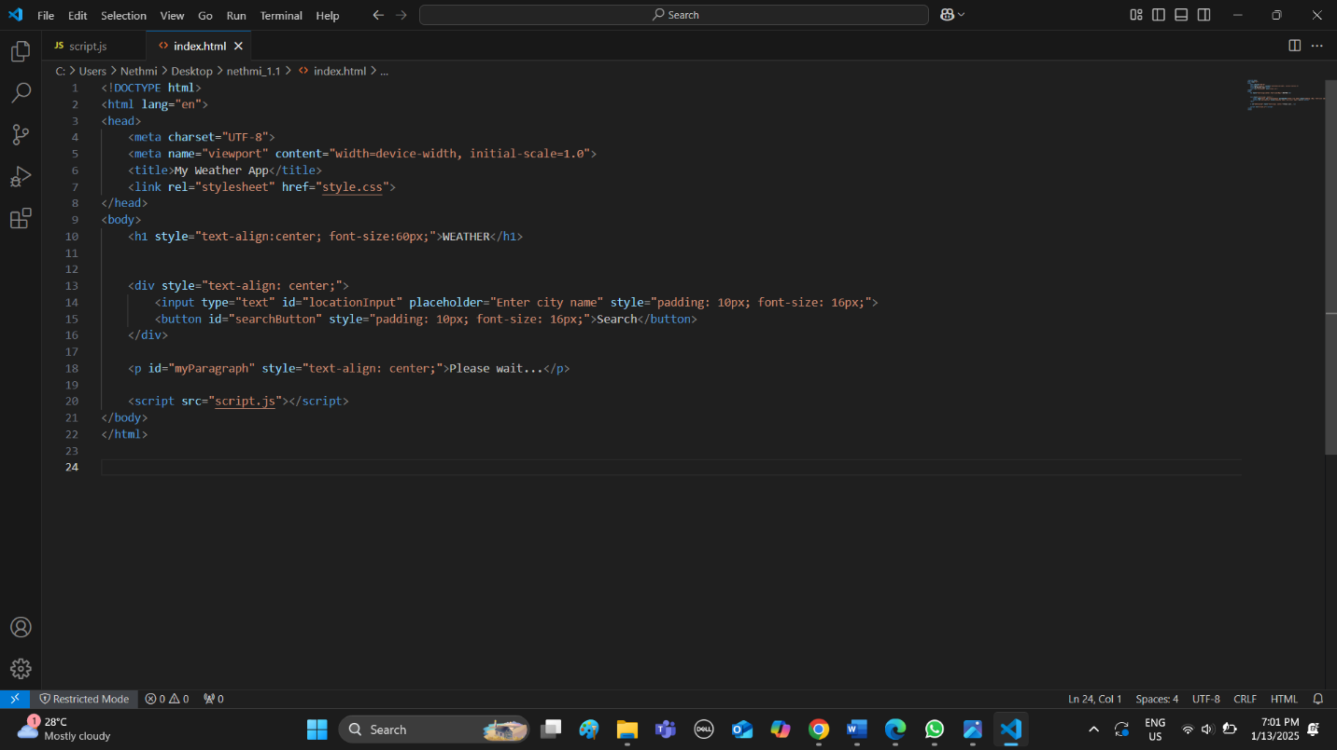
This is my CSS Code
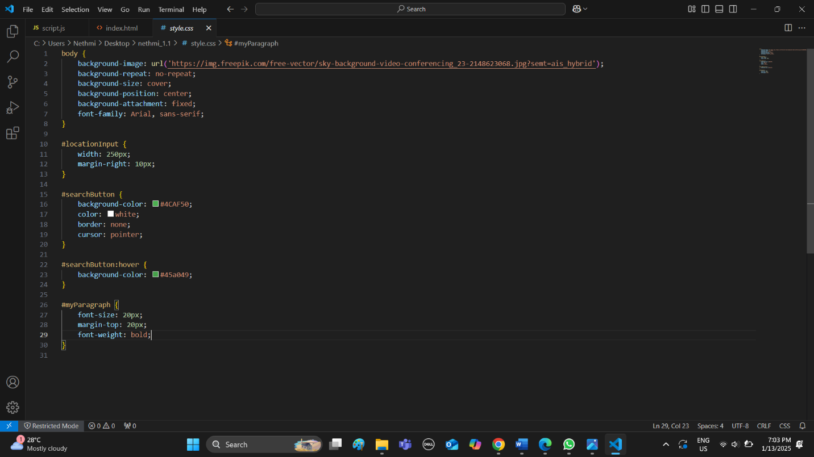This is my Java script Code
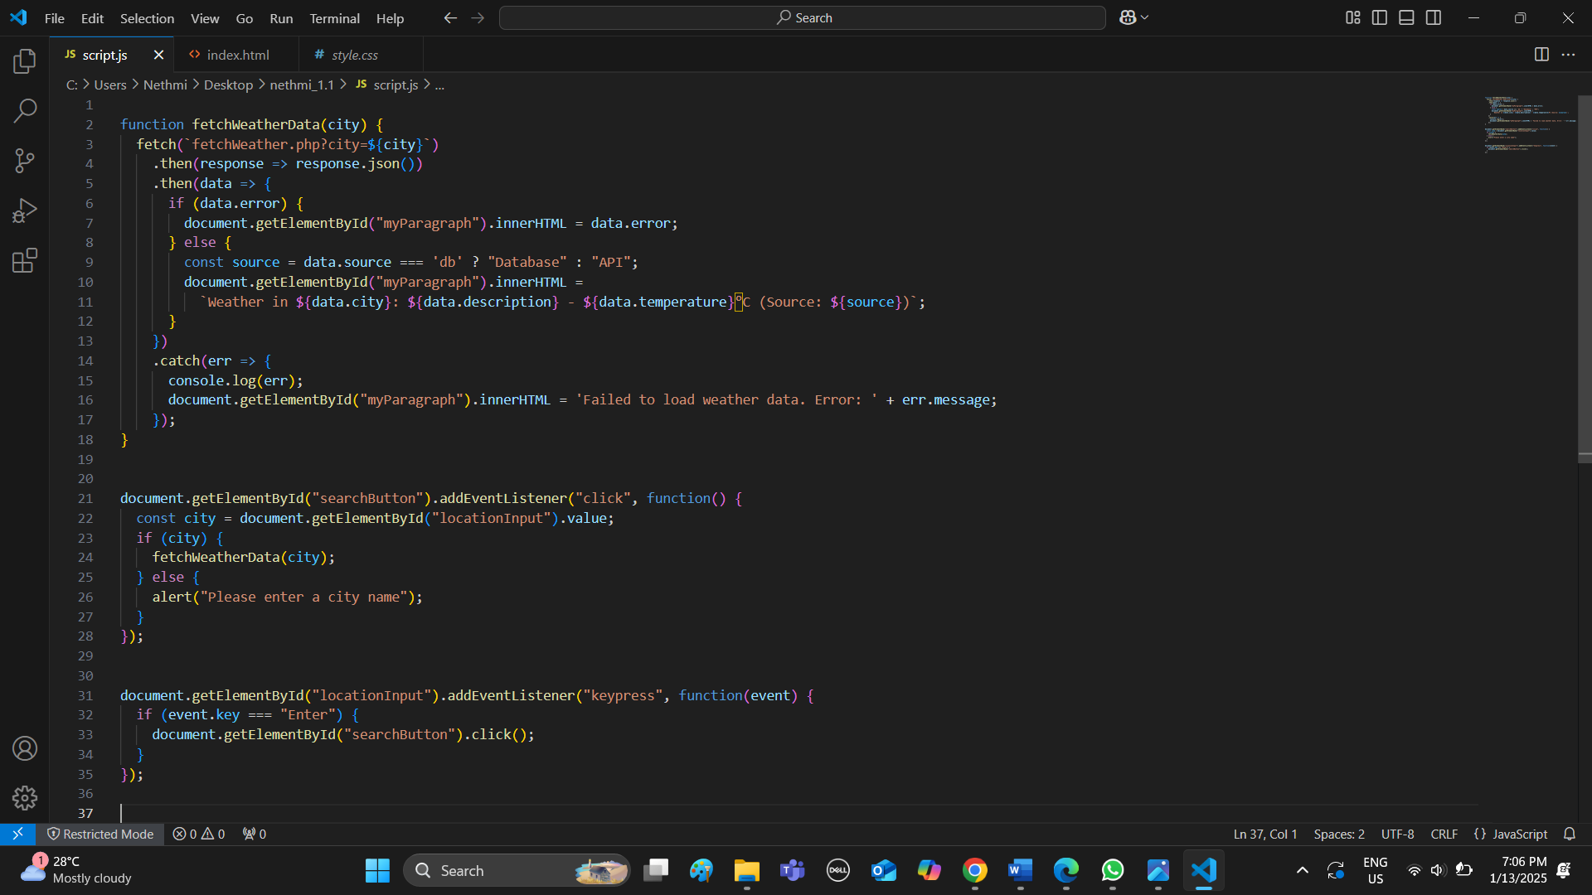This is my PHP Code
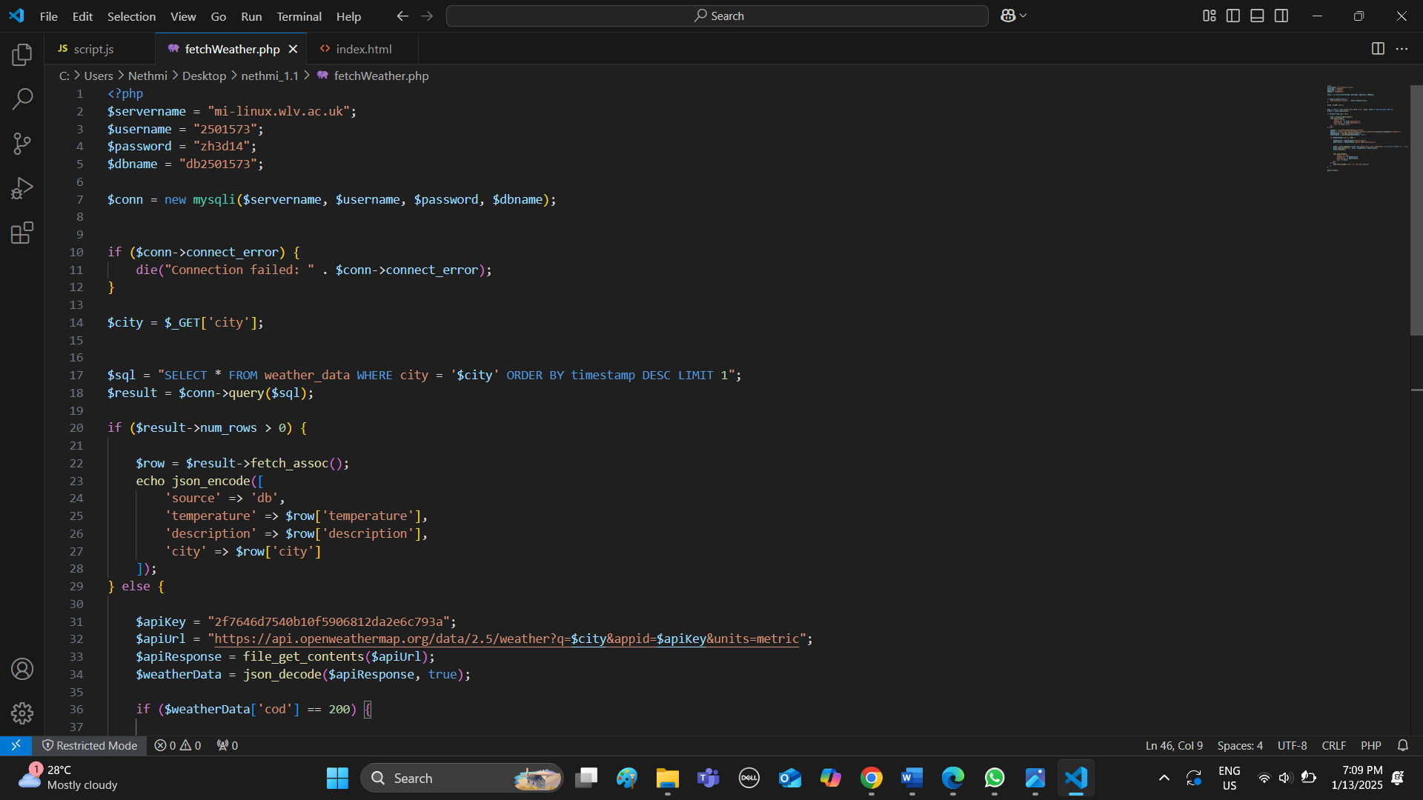

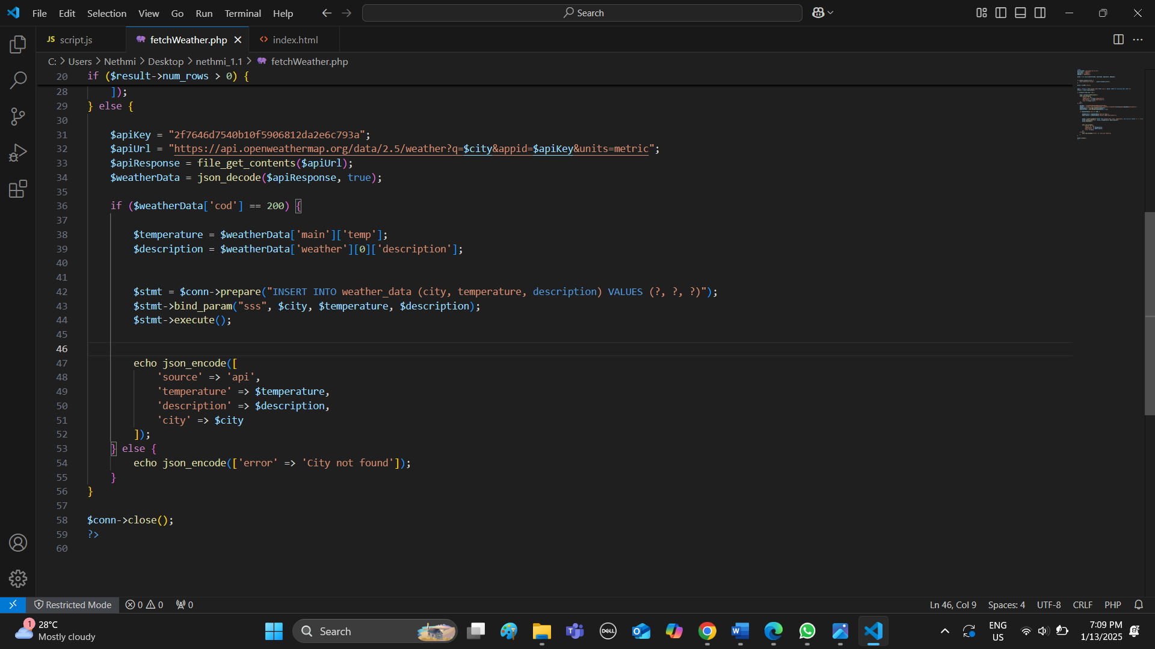

This is my database
